iMarket : An Intelligent Shopping Assistant

Jumana Fahad Al-Mahmoud, Reema Al-Helwah Amal AlOsaimi, Bushra AlAhmadi,
Bashayer AlThubaiti, Munirah AlNassar, Nuha AlDekhyl, Sara AlGhunaim

King Saud University, Riyadh, Saudi Arabia

Supervised by
Dr.Lilac AlSafadi

ABSTRACT

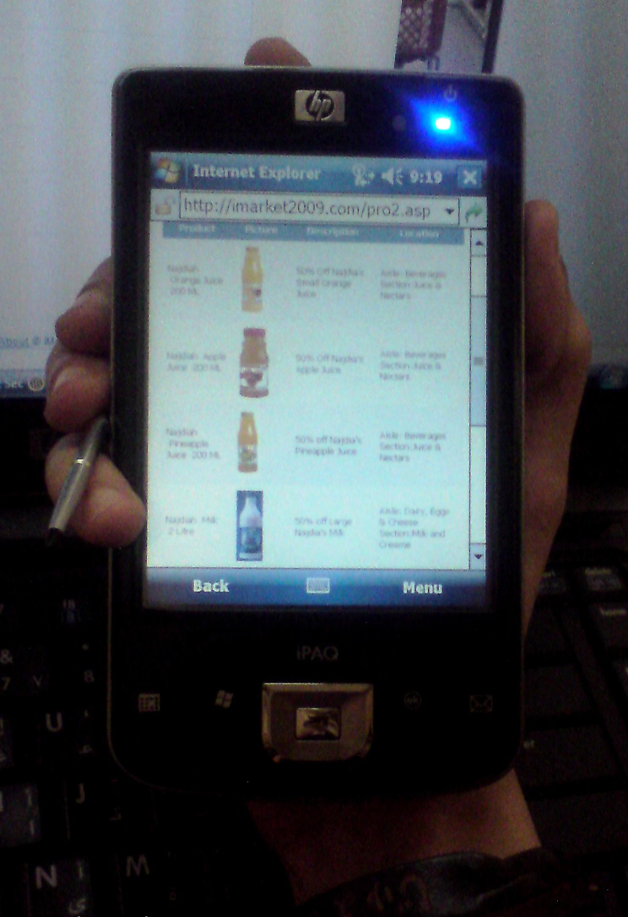
iMarket is a mobile-based intelligent shopping assistant, that improves customers shopping experience in supermarkets through the use of their mobile phones. iMarket is a website that provides customers with many services from creating and managing multiple shopping lists, managing and sharing product recipes, retrieving up-to-date product’s information, finding products in a supermarket, personalize recommendations on products and promotions, use adapted Shopping list for saving money, perform automatic checkout and payment. It can be accessed from any web-enabled mobile phone or PC.

iMarket's goal is to grasp the opportunity of utilizing modern technologies such as RFID (Radio frequency identification) embedded in the next generation of mobile phones, along with Buiness Intelligence (BI) techniques to help improve the shopping experience as well as marketing. RFID is a technology similar in theory to bar code identification. It transmits the product’s identity, in the form of a unique serial number, wirelessly using radio waves.

The recommendation system in iMarket, provides predictions of customers shopping behavior by performing analysis on their demographic features and purchase history. Recommendation is achieved by using K-Means Clustering algorithm, K-Nearest Neighbor Classification algorithm, and Market Basket Analysis algorithm. The adaption method, implemented using Constraint Satisfaction Problem intelligent algorithm, helps customers save money. This is done by replacing the products in their grocery lists with other products from different manufacturers with lower prices. Recommendation, adaption and optimization are what make iMarket “intelligent”.

As a result, customers, supermarkets, and the environment all benefit from using the iMarket system. For supermarkets, the system helps to understand customers' needs which will attract more customers. It also increases products' sales using targeted recommendations and promotions. It can reduce supermarket's expenses by limiting the number of cashiers (human resources), build long term relationship with customers and provide a fast checkout process to retain current customers. As for customers, iMarket reduces the transaction cost, search cost and cognitive energy, provides customers with customized promotions, suggest personalized recommendations on products according to their demographic features and purchasing behavior and help customers save money by monitoring and controlling their budget and alerting them when exceeding their threshold. It also provides customers with an alternative grocery list which contains their needs but with a lower price. In addition, iMarket helps reducing time wasted in long queues, by implementing auto-checkout feature and prepayment system. iMarket is a "green" device, since it is environment-friendly and creates a paperless environment eliminating the use of flayers and receipts.

While preserving the tradition of shopping, adding the flavor of technology would create the best convenient shopping experience. iMarket was developed with this concept in mind. Overall, the results indicate that a connection of BI and RFID has powerful business potential that goes well beyond operational improvements. The benefits and of course costs of a BI Infrastructure for data integration, refinement, and analysis should therefore not be neglected in a cost-benefit evaluation for RFID.

